Rayne - Rayne is a treasure of rural Americana spiced with Cajun charm - not to mention cuisine. The Frog Capital of the World and The Louisiana City of Murals welcomes every traveler with warm hospitality.

Zydeco Cajun Prairie Tour

Day 1

Maison Daboval House – Martha and Gene Royer, charming French Acadian natives to Rayne. The home was built in 1892 by Emile Daboval, the sixth mayor of Rayne have lovingly restored Maison Daboval to its original elegance and charm. During the restoration Gene and Martha found many discoveries about the home. (http://www.dabovalbb.com)
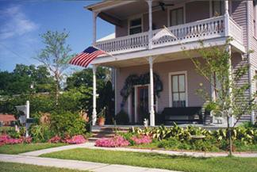

In the tradition of Cajun hospitality, the Royer’s will share nostalgic stories of couples falling in love during the bygone era of the railroad boarding house.

St. Joseph Church and cemetery which dates back to 1872 and see the famous cemetery that is the only cemetery in the U.S. where the graves run from North to South instead of East to West.
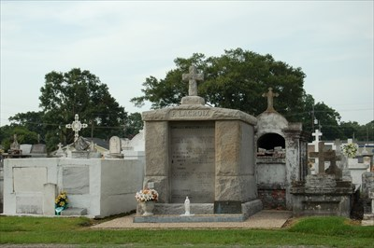

Stop at Antiques on the Avenue to meet owners, Ann and Eddie Palmer.

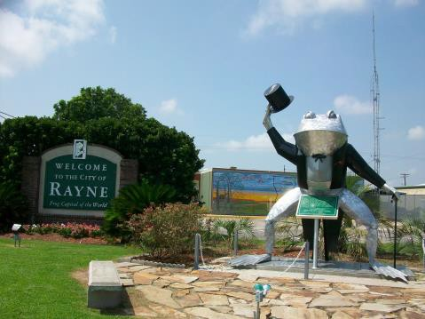

Enjoy a delicious lunch at Chef Roy’s Frog City Café Chef Benoit Morel and Mr. Robert Credeur, owners of Chef Roy's Frog City Cafe, invite you to dine with them for "The finest dining experience in all of Acadiana right here in Rayne."
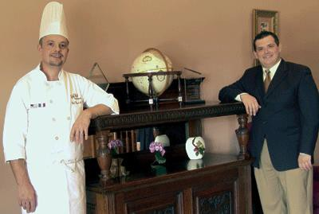

Head to Roberts Cove, Louisiana, a small community just outside of Rayne, founded by German settlers and today is made up almost entirely of descendants of thirteen original families. These families continued to grow and blend until family reunions were eventually combined into a full-fledged festival—the Annual Roberts Cove German Fest. Today, German Fest is essentially still a family reunion, celebrating German culture which has been passed down through the generations and shared with visitors from far and wide.

Tour the German Heritage Museum – The museum was built to preserve the history and heritage of this unique area in Cajun country. We will hear the history of the area, see a sauerkraut demonstration and hear German music played on the accordion by a local musician. Tour the Little Chapel on the beautiful grounds of the museum.
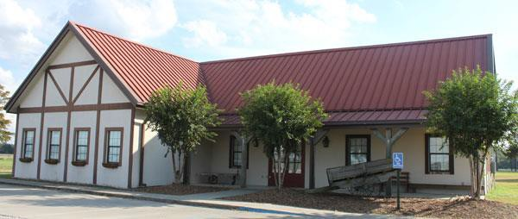
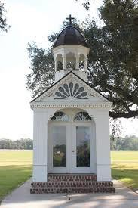

Candyland Cottage & Ice Cream Shoppe – While enjoying an ice cream cone or ice cream sundae, take a look at the old fashioned surroundings made up of antiques of all sorts, old fashion candies and pictures. Reminisce about the things you see that remind you of your childhood, including vintage candy and a display of all versions of the Candy Land game since it was created in 1949.
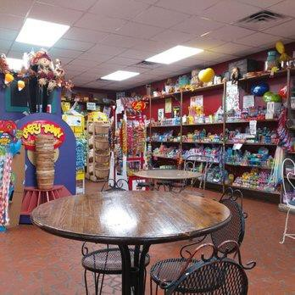

Stop at Sew What Cajun Mardi Gras Costume Shop - Meet owner, Mrs. Karen, and explore the costume shop where most of the unique Cajun Mardi Gras costumes are created and shipped throughout the world. (www.vacajun.com/)
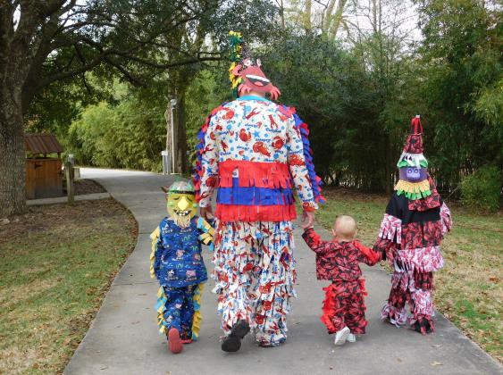

Day 2

Church Point, Louisiana

Church Point, Louisiana – This quaint town began in 1843, along a curve or point of the bayou. The first chapel here led to the town’s name La Pointe de L’eglise, or Church Point. The many people who traveled to church here via horse and buggy led to its claim as the “Buggy Capital of the World”!

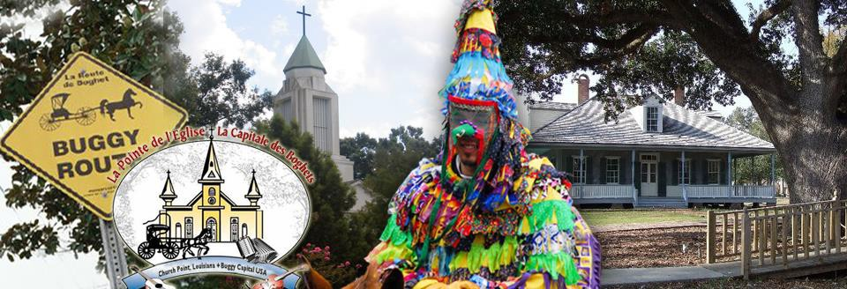

Tour by appointment: Le Vieux Presbytere – Constructed in 1887 as the priest’s home, this landmark serves at the museum for the cultural history of the town. Le Vieux Presbytere is of state significance in the area of architecture as a rare and important example of a method of construction associated with Louisiana's very significant French Creole architectural tradition. This is one of the last structures in south Louisiana to use the folk craft of mud wall construction which is known as bousillage, a primary characteristic of Louisiana's Creole architectural heritage.
Richard, Louisiana

Stop by the Little Cajun Saint grave in Richard, Louisiana – Charlene Richard was a twelve-year-old Roman Catholic Cajun girl from Richard, Louisiana. She has become the focus of a popular belief that she is a saint—a person who is in heaven—who has performed a number of miracles. The Roman Catholic Church has not given any official approval or begun any processes leading towards her canonization, but local Catholic clergy and diocesan officials have permitted, promoted and participated in the popular veneration of Richard. Over 10,000 people visit her grave every year from across the globe and leave a prayer intention. (www. http://holymotherchurch.org/1515298.html)
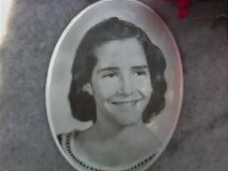

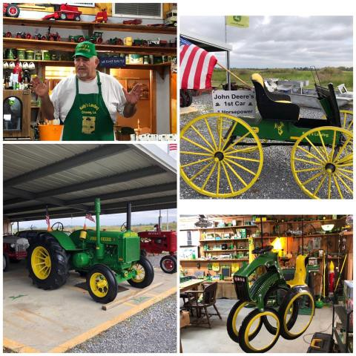

Lunch at Kelly’s Landing – The Cajun Prairie Farm - Meet owners, Kelly and Lynn and enjoy a delicious home cooked lunch while Kelly shares funny stories of his life as a rice and crawfish farmer, his tales of collecting antique farm equipment and a huge toy tractor collection. Take a nostalgic walk through the past as you view the farming tools of our fathers and grandfathers and his extensive John Deere toy collection. Kelly’s personality is as big as his farm and will keep you laughing while Miss Lynn’s hospitality will warm your heart!

Crowley, Louisiana

Mouton’s Music Store
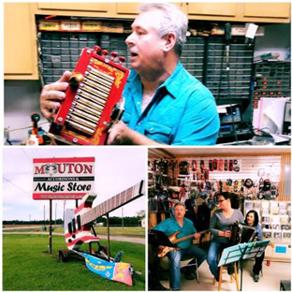

Mouton’s Music Store – Meet Greg Mouton and a few of his Cajun musician students at the world famous Mouton’s Music Store. The Mouton's have been building accordions since 1960, and they are known as the oldest running Cajun accordion label. They specialize in Louisiana music and the Cajun culture while at the same time promoting all types of music! (www.Moutonmusic.com)

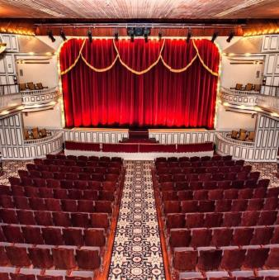

Crowley, Louisiana sits one of the most unique second-story opera houses still standing. Built in 1901 by David E. Lyons, a livery stable owner and deputy sheriff, the Grand, as it was named then, was referred to by the Daily Signal as a "beautiful little playhouse." Costing a mere $18,000 to build, Mr. Lyons carefully constructed his masterpiece using virgin Louisiana cypress, pine and oak. This mostly wooden structure was accented with pressed tin tiles and hand-painted angel medallions in the four boxed seats. The Grand was known as the place for entertainment and hospitality. Used mainly for vaudeville and minstrel performances in the earlier days and for silent movies and talkies during the later days, the Grand attracted people traveling through the South, specifically those passing through Crowley via the railroad, which was located just a few blocks from the opera house. (www.thegrandoperahouse.org)

Tour Grand Opera House - Tucked away in the heart of historical downtown
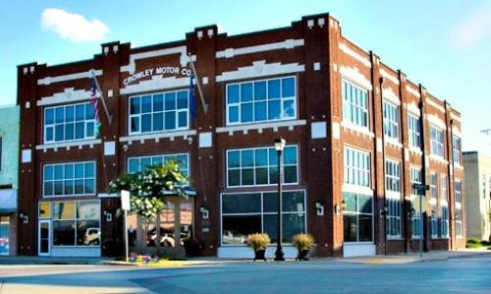

Motor Co/City Hall - Built in 1920 at the cost of $40,000.00 the Crowley Motor Co. was the city's Ford Motor Model T dealership. Designed by an architect for the Ford Motor Co, it was one of 1,000 similar Ford dealerships constructed in the U.S. The City of Crowley purchased the building in 2000, restoration began in August 2006 City Hall moved in. The building is also home to four museums: The Rice Interpretive Center, the History of Crowley, J.D.Miller Music Recording Studio and Ford Automotive Museums. (www.acadiatourism.org/attraction/detail/crowley-motor-co-ford-building)

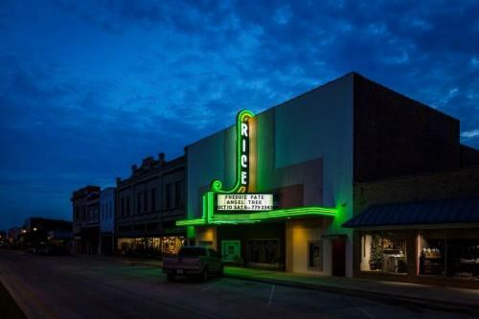

Historic Rice Theatre - Opened January 31, 1941 (after a delay in construction in 1940 due to flooding) at a cost of about $100,000. The opening movie, “This Thing Called Love” starring Rosalind Russell. The 1,000-seat Art Modern style theatre seated 700 on the orchestra level and another 300 in the balcony. The theatre closed in late-October 1983, and remained vacant for almost 20 years before the Rice Theatre was acquired by the city of Crowley in 1986 for the Rice City Civic Center (“The Rice City” being Crowley’s nickname). (www.cinematreasures.org/theaters/8853/photos

