PROCEEDINGS OF THE MAYOR AND THE BOARD OF ALDERMEN OF THE CITY OF RAYNE, STATE OF LOUISIANA, TAKEN AT A REGULAR MEETING, HELD ON SEPTEMBER 14, 2020. NOTE: MEETING VIA ZOOM ON COMPUTER-BROADCAST OUTSIDE FOR ANY OVERFLOW.

The Mayor and Board of Aldermen of the City of Rayne, Louisiana, met in regular session at City Court located at 301 E Louisiana Avenue, Rayne, Louisiana, on Monday, September 14, 2020 at 6:00 (six) o’clock p.m.

There were present: Mayor Charles E. “Chuck” Robichaux, Lendell J. “Pete” Babineaux, Curtrese L. Minix, Kenneth J. Guidry, Calise Michael Doucet and James A. “Jimmy” Fontenot.

There were absent: None.

The Mayor and the Board of Aldermen of the City of Rayne, State of Louisiana, were duly convened as the governing authority of said City, by Mayor Charles E. “Chuck” Robichaux, who stated that the Board was ready for the transaction of business.

There was a motion by Calise Michael Doucet to approve, correct, and dispense with the reading of minutes of the August regular council meeting and approved them as written and distributed. This was seconded by Kenneth J. Guidry and motion carried.
YEAS: 5 – Curtrese L. Minix, Kenneth J. Guidry, Lendell J. “Pete” Babineaux, Calise Michael Doucet and James A. “Jimmy” Fontenot.
NAYS: 0 ABSTAIN: 0 ABSENT: 0

On a motion by Calise Michael Doucet and a second by Lendell J. “Pete” Babineaux a public hearing was opened for the purpose of a public discussion on Ordinance#2020-An Ordinance to Amend the City of Rayne’s October 1, 2019- September 30, 2020 Budget, Ordinance#2021-An Ordinance to adopt an Operating Budget of Revenues and Expenditures for the fiscal year beginning October 1, 2020 and ending September 30, 2021 and Ordinance#2022- An Ordinance to Sell Property Not needed for Public Purposes.
YEAS: 5 – Curtrese L. Minix, Kenneth J. Guidry, Lendell J. “Pete” Babineaux, Calise Michael Doucet and James A. “Jimmy” Fontenot.
NAYS: 0 ABSTAIN: 0 ABSENT: 0

There were no speaker cards, so other than the budget presentations by City Clerk, Annette Cutrera with questions from the Council, Mayor, there were no public comment.

On a motion by Lendell J. “Pete” Babineaux and a second by Kenneth J. Guidry a public hearing for the purpose of public discussion Ordinance#2020, Ordinance#2021-An Ordinance to adopt an and Ordinance#2022
YEAS: 5 – Curtrese L. Minix, Kenneth J. Guidry, Lendell J. “Pete” Babineaux, Calise Michael Doucet and James A. “Jimmy” Fontenot.
NAYS: 0 ABSTAIN: 0 ABSENT: 0

Curtrese L. Minix introduced Ordinance# 2023- An Ordinance to set the compensation of the City Prosecutor.

On a motion by Calise Michael Doucet and a second by James A. “Jimmy” Fontenot to hold a public hearing on October 12, 2020 for the purpose of public discussion about Ordinance# 2023- An Ordinance to set the compensation of the City Prosecutor was carried.
YEAS: 5 – Curtrese L. Minix, Kenneth J. Guidry, Lendell J. “Pete” Babineaux, Calise Michael Doucet and James A. “Jimmy” Fontenot.
NAYS: 0 ABSTAIN: 0 ABSENT: 0

The following ordinance was offered by Lendell J. “Pete” Babineaux, duly seconded by Calise Michael Doucet and duly resolved and adopted on 14th day of September 2020.
ORDINANCE NO. 2020
AN ORDINANCE AMENDING THE CITY OF RAYNE BUDGET OF REVENUES AND EXPENDITURES FOR THE FISCAL YEAR BEGINNING OCTOBER 1, 2019 AND ENDING SEPTEMBER 30, 2020.

BE IT ORDAINED by the Mayor and Board of Alderman of the City of Rayne, State of Louisiana:

Section 1.
The attached detailed amended Schedule of Revenues for the fiscal year beginning October 1, 2019 and ending September 30, 2020 be and the same is hereby adopted to serve as an Operating Budget of Revenues for the City of Rayne during the same period.

Section 2.
The attached amended Schedule of Expenditures by department for the fiscal year beginning October 1, 2019 and ending September 30, 2020 be and the same is hereby adopted to serve as a Budget of Expenditures for the City of Rayne during the same period.

Section 3.
The adoption of this amended Operating Budget of Expenditures be and the same is hereby declared to operate as an appropriation of the amount therein set forth within the terms of the budget classification.

Section 4.
Amounts are available for expenditures only to the extent included within the terms of the 2019-2020 budget.
Section 5.
After being considered section by section and being put to a vote on the whole, the vote thereon was as follows:

YEAS: 5 – Curtrese L. Minix, Kenneth J. Guidry, Lendell J. “Pete” Babineaux, Calise Michael Doucet and James A. “Jimmy” Fontenot.

NAYS:

ABSENT:

And the said ordinance was therefore declared adopted on this 14th day of September, 2020.

________________________________ _________________________________
CHARLES E. ROBICHAUX, MAYOR ANNETTE R. CUTRERA, CITY CLERK

The above ordinance was presented to the Mayor by the Clerk, approved by the Mayor and returned to the Clerk on this 14th day of September, 2020.

_______________________________ _________________________________
CHARLES E. ROBICHAUX, MAYOR ANNETTE R. CUTRERA, CITY CLERK
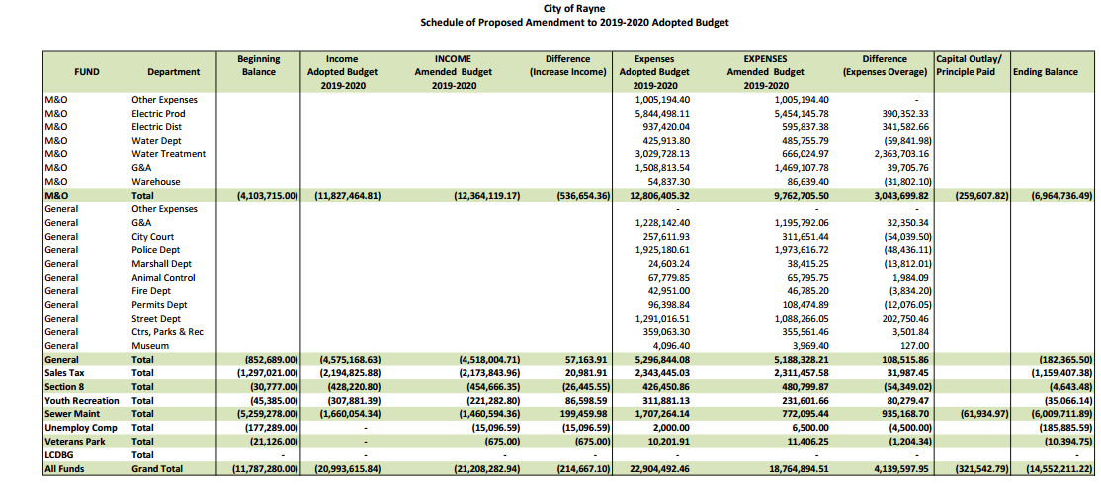

The following ordinance was offered by Calise Michael Doucet , duly seconded by Curtrese L. Minix, and duly resolved and adopted on 14th day of September, 2020.

ORDINANCE NO. 2021

AN ORDINANCE ADOPTING AN OPERATING BUDGET OF REVENUES AND EXPENDITURES FOR THE FISCAL YEAR BEGINNING OCTOBER 1, 2020 AND ENDING SEPTEMBER 30, 2021.

BE IT ORDAINED by the Mayor and Board of Alderman of the City of Rayne, State of Louisiana:

Section 1.
The attached detailed estimate of Revenues for the fiscal year beginning October 1, 2020 and ending September 30, 2021 be and the same is hereby adopted to serve as an Operating Budget of Revenues for the City of Rayne during the same period.

Section 2.
The attached estimate of Expenditures by department for the fiscal year beginning October 1, 2020 and ending September 30, 2021 be and the same is hereby adopted to serve as a Budget of Expenditures for the City of Rayne during the same period.

Section 3.
The adoption of this Operating Budget of Expenditures be and the same is hereby declared to operate as an appropriation of the amount therein set forth within the terms of the budget classification.

Section 4.
Amounts are available for expenditures only to the extent included within the terms of the 2020-2021 budget.
Section 5.
After being considered section by section and being put to a vote on the whole, the vote thereon was as follows:

YEAS: 5 – Curtrese L. Minix, Kenneth J. Guidry, Lendell J. “Pete” Babineaux, Calise Michael Doucet and James A. “Jimmy” Fontenot.

NAYS: 0

ABSENT: 0

And the said ordinance was therefore declared adopted on this 14th day of September, 2020.

_______________________________ __________________________________
CHARLES E. ROBICHAUX, MAYOR ANNETTE R. CUTRERA, CITY CLERK

The above ordinance was presented to the Mayor by the Clerk, approved by the Mayor and returned to the Clerk on this 14th day of September, 2020.

________________________________ __________________________________
CHARLES E. ROBICHAUX, MAYOR ANNETTE R. CUTRERA, CITY CLERK

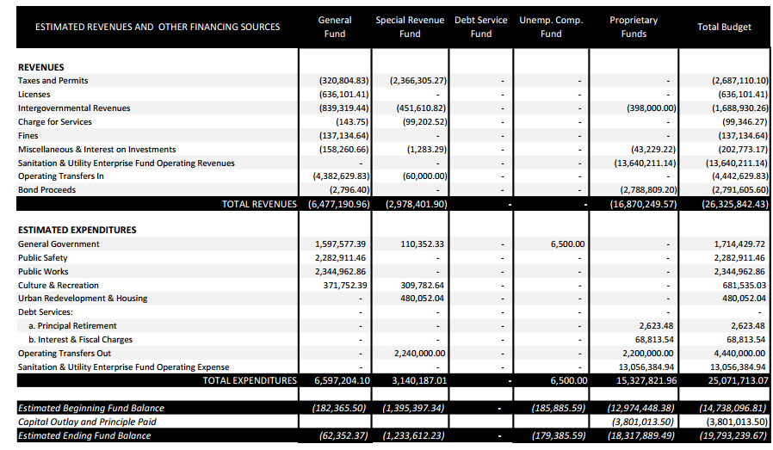

ORDINANCE NO. 2022

An Ordinance to Sell Property Not needed for Public Purposes.

BE IT ORDAINED by the Board of Alderman of the City of Rayne, Louisiana, that this Ordinance is hereby enacted to read as follows:

The City of Rayne shall sell to Albert L. Frank and Mary Hamilton Frank one tract of land no longer needed for public purposes for the sum of Three Thousand Four Hundred Forty-five and 49/l00 ($3,445.49), and being described as follows:

That certain tract or parcel of land, together with all buildings
and improvements thereon, situated in the City of Rayne,
designated as Lots 5 & 8, Blk 40 Ealer, with a municipal address
of 606 Live Oak Street, Rayne, Louisiana 70578.

After being considered section by section and being put to a vote on the whole, the vote thereon was as follows:

YEAS: 5 – Curtrese L. Minix, Kenneth J. Guidry, Lendell J. “Pete” Babineaux, Calise Michael Doucet and James A. “Jimmy” Fontenot.

NAYS:

ABSENT:

And the said ordinance was therefore declared adopted on this 14th day of September 2020.

________________________________ _________________________________
CHARLES E. ROBICHAUX, MAYOR ANNETTE R. CUTRERA, CITY CLERK

The above ordinance was presented to the Mayor by the Clerk, approved by the Mayor and returned to the Clerk on this 14th day of September, 2020.

________________________________ __________________________________
CHARLES E. ROBICHAUX, MAYOR ANNETTE R. CUTRERA, CITY CLERK

On a motion by James A. “Jimmy” Fontenot and a second by Lendell J. “Pete” Babineaux to reject the adoption of millage rates for the 2020- tax year was carried.
YEAS: 4 – Curtrese L. Minix, Kenneth J. Guidry, Lendell J. “Pete” Babineaux, Calise Michael Doucet and James A. “Jimmy” Fontenot.
NAYS: 1– Kenneth J. Guidry ABSTAIN: 0 ABSENT: 0

The City Clerk, Mrs. Annette R. Cutrera, presented the City of Rayne Monthly Financial Update as of August 31,2020 which included budget to actual comparisons on the major funds to the Council.

Daniel Landry addressed the council.

Scott Privat addressed the council.

Tiffany Thibodeaux of Thibodeaux’s Accounting presented her audit report for the City of Rayne.

On a motion by James A. “Jimmy” Fontenot and a second by Curtrese L. Minix to consider authorizing the submittal of FY’ 2021-2022 State of Louisiana Capital Outlay Requests for 1) the MLK Community Center improvements and 2) The Gossen Memorial Concession Stand projects was carried.
YEAS: 5 – Curtrese L. Minix, Kenneth J. Guidry, Lendell J. “Pete” Babineaux, Calise Michael Doucet and James A. “Jimmy” Fontenot.
NAYS: 0 ABSTAIN: 0 ABSENT: 0

On a motion by Curtrese L. Minix and a second by Kenneth J. Guidry to consider authorizing Mader Engineering, Inc. to prepare the FY’ 2021-2022 State of Louisiana Capital Outlay Requests for these 1) the MLK Community Center improvements and 2) The Gossen Memorial Concession Stand projects was carried.
YEAS: 5 – Curtrese L. Minix, Kenneth J. Guidry, Lendell J. “Pete” Babineaux, Calise Michael Doucet and James A. “Jimmy” Fontenot.
NAYS: 0 ABSTAIN: 0 ABSENT: 0

On a motion by James A. “Jimmy” Fontenot and a second by Curtrese L. Minix to consider the request for a variance from Gloria Francis, as approved by the Planning & Zoning Board, to put a double wide mobile home on her property at 715 Crandle. The home will violate the city’s setback requirements of 20’ on the front and 10’ corner lot side. The property is zoned R-3, was carried.
YEAS: 5 – Curtrese L. Minix, Kenneth J. Guidry, Lendell J. “Pete” Babineaux, Calise Michael Doucet and James A. “Jimmy” Fontenot.
NAYS: 0 ABSTAIN: 0 ABSENT: 0

There being no further business to come before the Council, there was a motion by Curtrese L. Minix that the meeting be adjourned, this was seconded by Calise Michael Doucet and carried.
YEAS: 5 – Curtrese L. Minix, Kenneth J. Guidry, Lendell J. “Pete” Babineaux, Calise Michael Doucet and James A. “Jimmy” Fontenot.
NAYS: 0 ABSTAIN: 0 ABSENT: 0

________________________________ __________________________________
CHARLES E. ROBICHAUX, MAYOR ANNETTE R. CUTRERA, CITY CLERK

